Hospital Management System (HOMS)

1. Introduction
Hospital Management System (HOMS) is a software system used to manage hospital operations such as patient registration, doctor scheduling, appointment booking, treatment, admission, and billing.
In traditional systems, these tasks are done manually which leads to delays and errors. This system helps to automate the process, improve efficiency, and maintain accurate records.
The main focus of this system is patient-doctor interaction, where patients can easily consult doctors and receive proper treatment. 

2. Objectives
- To automate hospital activities
- To manage patient and doctor information
- To simplify appointment booking
- To store medical records properly
- To generate bills automatically
- To improve service quality and reduce errors

3. Functional Requirements
The system should be able to:
- Register new patients
- Allow patient login and profile management
- Show available doctors and their specialization
- Book, cancel, and reschedule appointments
- Allow doctors to view appointments
- Record diagnosis and prescription
- Admit patients when necessary
- Allocate rooms to patients
- Generate bills automatically
- Accept and record payments

4. Non-Functional Requirements
The system should:
- Provide fast response time
- Ensure data security and privacy
- Be user-friendly and easy to use
- Maintain data accuracy and consistency
- Support backup and recovery
- Be reliable and scalable

5. Use Case Modeling

Actors:
- Patient
- Doctor
- Receptionist
- Admin

Main Use Cases:
- Register Patient
- Login
- Book Appointment
- Check Doctor Availability
- Consult Patient
- Create Prescription
- Admit Patient
- Allocate Room
- Generate Bill
- Make Payment

Use Case Diagram:
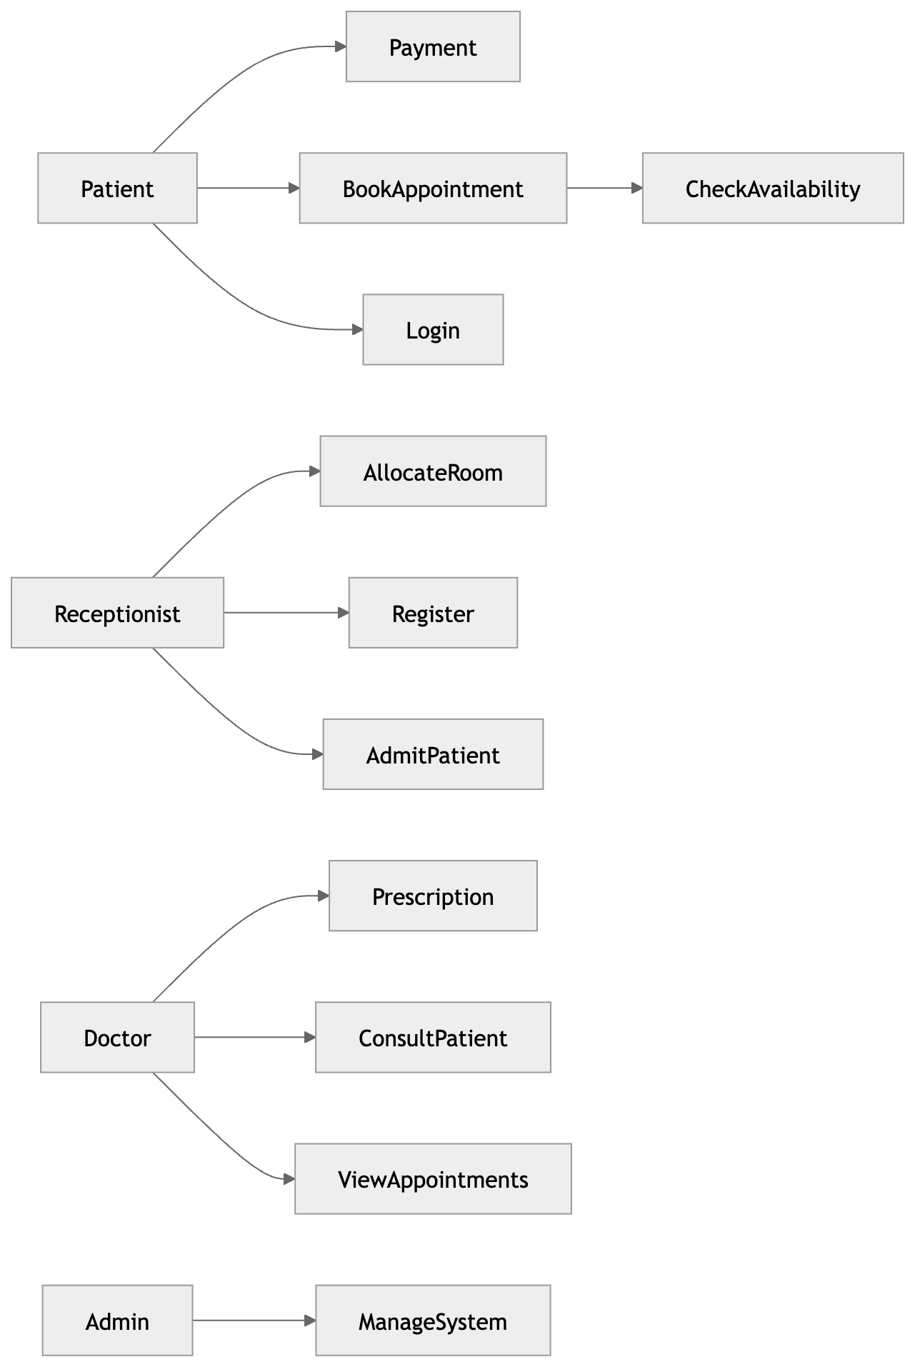

6. Structural Design (Class Diagram)

Main Classes:
- User
- Patient
- Doctor
- Appointment
- MedicalRecord
- Prescription
- Room
- Bill

Description:
- User is the parent class
- Patient and Doctor inherit from User
- Patient books appointments
- Doctor handles appointments
- MedicalRecord stores patient history
- Bill stores payment details

Attributes and Methods
User
- Attributes: id, name
- Method: login()
Patient
- Method: bookAppointment()
Doctor
- Method: diagnose()
Appointment
- Attributes: date, status
MedicalRecord
- Attribute: diagnosis
Prescription
- Attribute: medicine
Bill
- Attribute: amount

Class Diagram
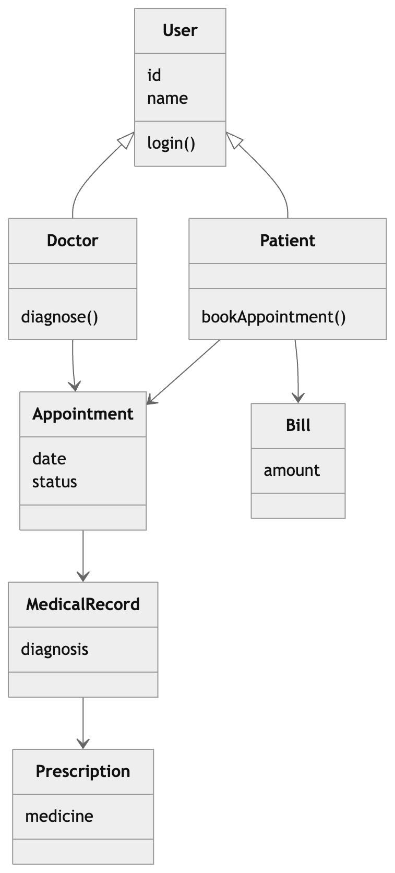

7. Database Design (ER Diagram)

7.1 Entities
- Patient
- Doctor
- Appointment
- Medical_Record
- Prescription
- Bill

7.2 Relationships
- Patient books Appointment
- Doctor attends Appointment
- Appointment creates Medical Record
- Medical Record generates Prescription
- Patient receives Bill

7.3 Suggested Primary Keys and Foreign Keys
PATIENT
- patient_id (PK)
- name
- age
- gender
- phone
DOCTOR
- doctor_id (PK)
- name
- specialization
- phone
APPOINTMENT
- appointment_id (PK)
- patient_id (FK)
- doctor_id (FK)
- date
- status
MEDICAL_RECORD
- record_id (PK)
- appointment_id (FK)
- diagnosis
PRESCRIPTION
- prescription_id (PK)
- record_id (FK)
- medicine
BILL
- bill_id (PK)
- patient_id (FK)
- amount

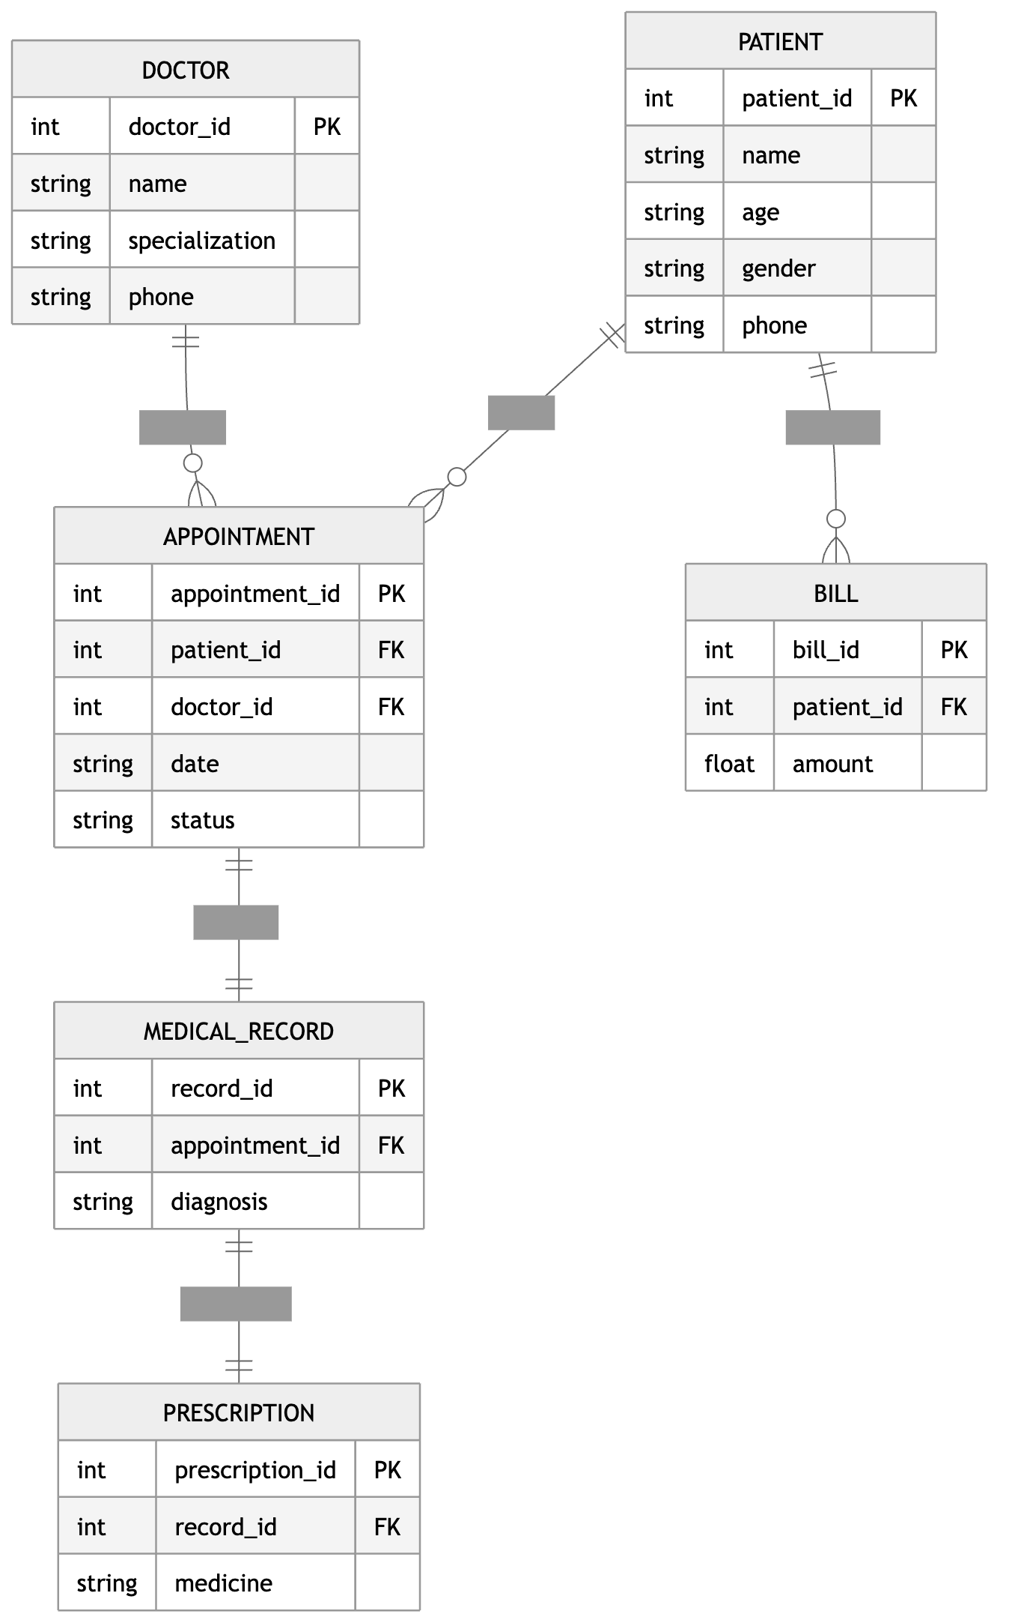

8. Advantages
- Reduces manual work
- Saves time
- Improves data accuracy
- Easy record management
- Better patient service

9. Limitations
- Requires technical knowledge
- System failure can affect work
- Initial setup cost is high

10. Conclusion
The Hospital Management System is an efficient solution for managing hospital activities. It improves patient-doctor interaction, reduces errors, and enhances overall hospital performance. The system ensures better service and organized data management.

